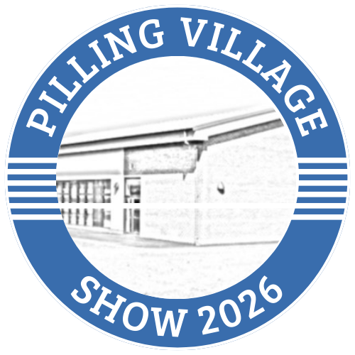

August 29th 2026
Pilling Village Hall, Taylors Lane, Pilling
Open to entries from outside of the village

Entries and staging 08.00 – 10.00am
Judging 10.30 – 12.30
Open to the public at 14.00
Free entry
Awards and raffle at 16.00
Refreshments by Pilling St Johns PTA

Enquiries and schedule from
Pillingshow2026@yahoo.com
Or via Lyn on 07501097236

