Walking and cycling survey
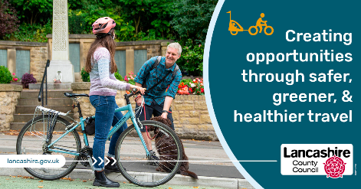

Everyone is invited to take part in a survey to help shape future plans for cycling and walking in Lancashire.

Lancashire County Council, in partnership with Blackpool Council, want to join up the gaps in our existing network of footpaths and cycle routes and provide safer, direct and more convenient routes.

Following feedback from our initial public engagement last year, the councils have produced a draft network map of cycling and walking networks routes in Lancashire. They need people from all areas of the county to provide feedback on anything you think could be improved. The survey will be available on their website until 24 October 2023.

Additional design and feasibility work will be needed to take any of the proposed schemes forward.

You can find out more and take part in the survey at www.lancashire.gov.uk/activetravel

